ICT-3200, Industrial Visit Report, Part-2
Kaliakoir Hi–Tech Park

Department of Information and Communication Technology
Mawlana Bhashani Science and Technology University

Contents
- Student Information 2
- Introduction 2
- Objectives 2
- Organization Overview 2
- Companies Visited 3
- Technologies Observed 3
- ICT Applications 4
- Learning Outcomes 4
- Challenges Observed 5
- Recommendations 5
- Conclusion 5
Appendix 6

1. Student Information
Name: Kuldip Saha Mugdha
Student ID: IT22018
Session: 2021–22
Semester: 3rd Year, 2nd Semester
Date of Visit: 21 July 2026
Submission Date: 3 August 2026

2. Introduction
As part of the ICT-3200 course, an industrial visit was organized to Kaliakoir Hi-Tech Park to provide students with practical exposure to Bangladesh's rapidly growing ICT industry. The visit aimed to familiarize students with modern technology-driven enterprises, ICT infrastructure, industrial innovation, and business automation practices. It also offered an opportunity to observe how theoretical concepts learned in the classroom are applied in real-world technology companies, fostering a better understanding of current industrial trends and professional practices.

3. Objectives
The primary objectives of the industrial visit were:
- To understand the role of Hi-Tech Parks in promoting the ICT industry in Bangladesh.
- To observe modern ICT infrastructure and industrial technologies.
- To gain knowledge of business automation and embedded system applications.
- To understand optical fiber manufacturing and communication technologies.
- To relate academic knowledge to practical industrial applications.
- To explore potential career opportunities in the ICT and telecommunication sectors.

4. Organization Overview
Kaliakoir Hi-Tech Park is one of Bangladesh's premier technology parks, established to accelerate the country's digital transformation and foster innovation within the ICT sector. The park provides world-class infrastructure and business support services for software companies, technology startups, research institutions, and multinational organizations.
It serves as a hub for innovation, entrepreneurship, and advanced technology development by offering office facilities, incubation support, research environments, and modern communication infrastructure. The park plays a significant role in attracting investment, generating employment opportunities, promoting local technology industries, and contributing to the vision of building a knowledge-based digital economy.

5. Companies Visited
During the industrial visit, two technology-based companies operating within Kaliakoir Hi-Tech Park were visited:
- Business Automation
- NovoCom Limited

Business Automation
Business Automation specializes in developing technology solutions for the banking and financial sector. During the visit, students learned about the design and development of token generator machines widely used by banks across Bangladesh. The company demonstrated how embedded systems, secure software solutions, and automation technologies are integrated to improve operational efficiency, customer service, and transaction security.

NovoCom Limited
NovoCom Limited is involved in the manufacturing of optical fiber products for modern telecommunication networks. The visit provided insight into the production process of optical fiber cables, quality assurance procedures, and testing methods used to ensure high-speed and reliable data transmission. Students also gained a better understanding of the importance of fiber optic technology in modern communication systems.

6. Technologies Observed
The following technologies and systems were observed during the visit:
- Banking automation systems
- Embedded systems for financial devices
- Token generator machine development
- Optical fiber manufacturing technologies
- Fiber optic testing and quality assurance techniques
- Modern ICT infrastructure
- High-speed networking and communication technologies

7. ICT Applications
Several practical applications of Information and Communication Technology were observed throughout the visit, including:
- Banking service automation
- Secure authentication and token generation systems
- Embedded software solutions
- Optical fiber communication technology
- Digital business process management
- High-speed communication infrastructure
- Technology-based product design and development
These applications demonstrate the growing importance of ICT in improving efficiency, security, and innovation across multiple industries.

8. Learning Outcomes
The industrial visit provided valuable practical knowledge and several important learning experiences:
- Understanding the role of Hi-Tech Parks in supporting technological innovation and economic development.
- Knowledge of banking automation systems and embedded technologies.
- Basic understanding of optical fiber manufacturing and communication systems.
- Exposure to modern industrial ICT infrastructure and professional working environments.
- Appreciation of quality assurance practices followed in technology industries.
- Increased awareness of career opportunities in software development, embedded systems, networking, and telecommunications.

9. Challenges Observed
The visit also highlighted several challenges faced by technology-driven industries:
- High capital investment required for advanced manufacturing and research facilities.
- Continuous technological advancement requiring regular system upgrades.
- Increasing demand for highly skilled engineers and ICT professionals.
- Maintaining international quality standards and product reliability.
- Ensuring cybersecurity and protection of digital systems against emerging threats.

10. Recommendations
Based on the observations made during the visit, the following recommendations are suggested:
- Strengthen collaboration between universities and technology industries.
- Expand internship, training, and industrial attachment opportunities for students.
- Encourage greater investment in research and innovation.
- Continue upgrading ICT infrastructure to remain globally competitive.
- Organize regular industrial visits to expose students to emerging technologies and industry practices.

11. Conclusion
The industrial visit to Kaliakoir Hi-Tech Park was an enriching and informative experience that provided valuable insights into Bangladesh's growing technology sector. Visiting Business Automation and NovoCom Limited enabled students to observe practical applications of business automation, embedded systems, and optical fiber manufacturing technologies. The experience successfully bridged the gap between theoretical learning and industrial practice while enhancing students' understanding of modern ICT applications, professional work environments, and future career opportunities. Overall, the visit significantly contributed to both academic learning and professional development.

Appendix
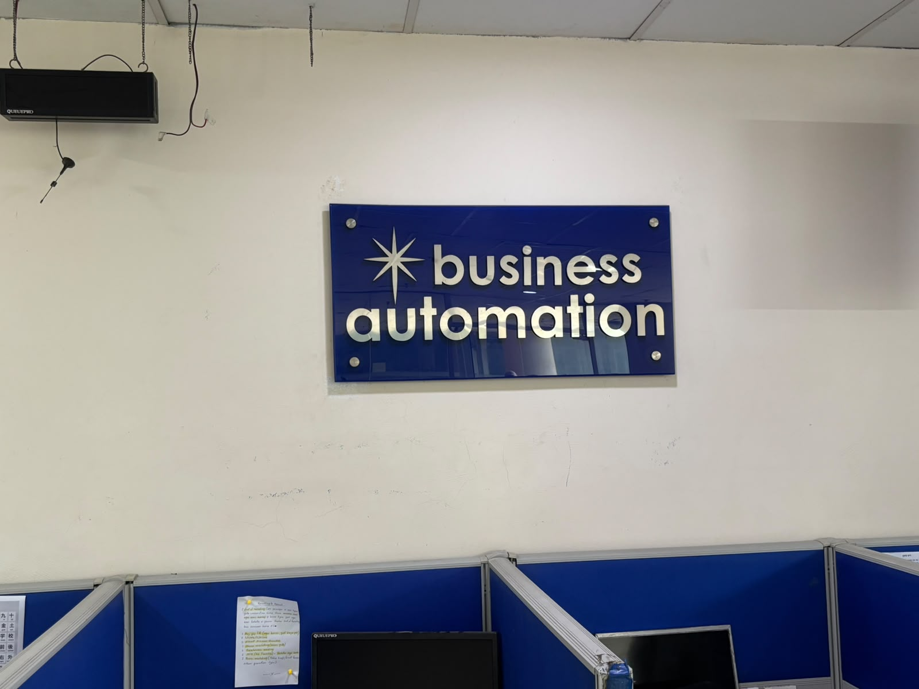
First Company Visit in High Tech Park
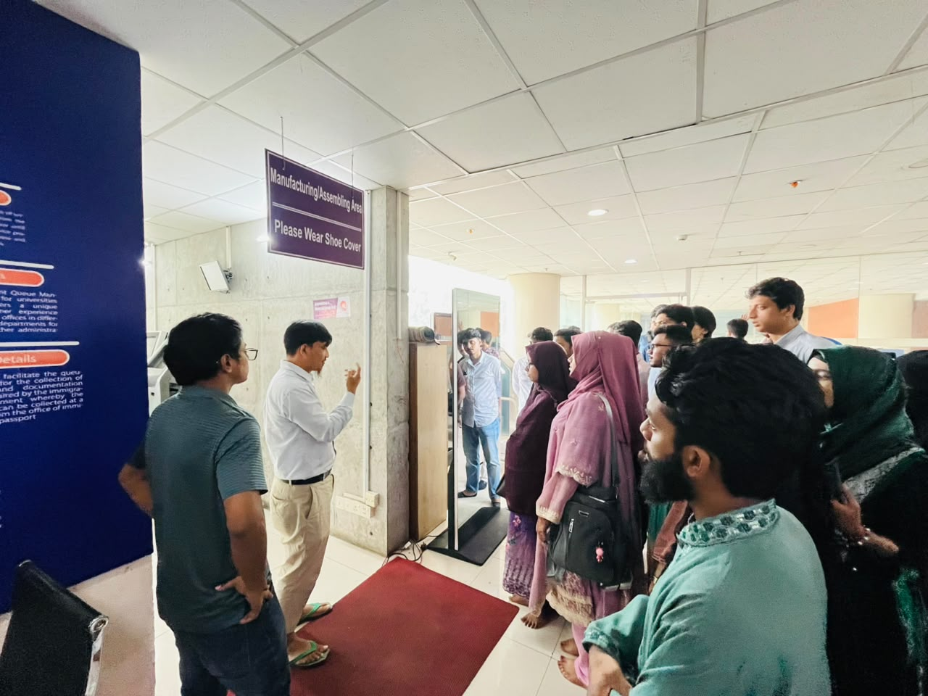
Short Briefing Before Entering Business Automation Factory

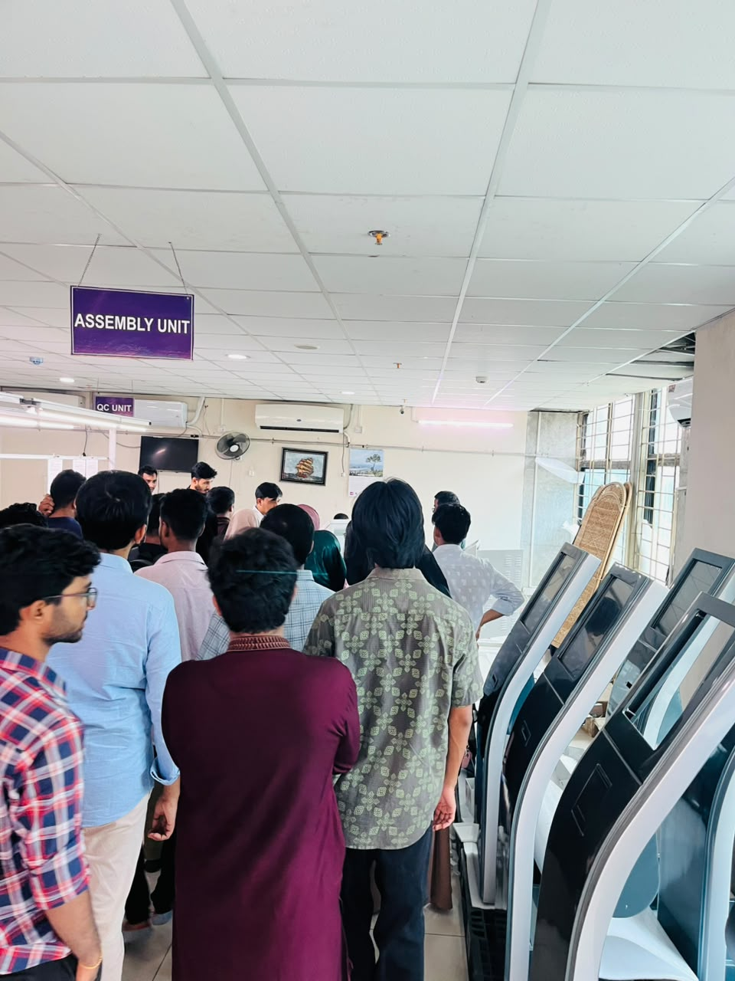
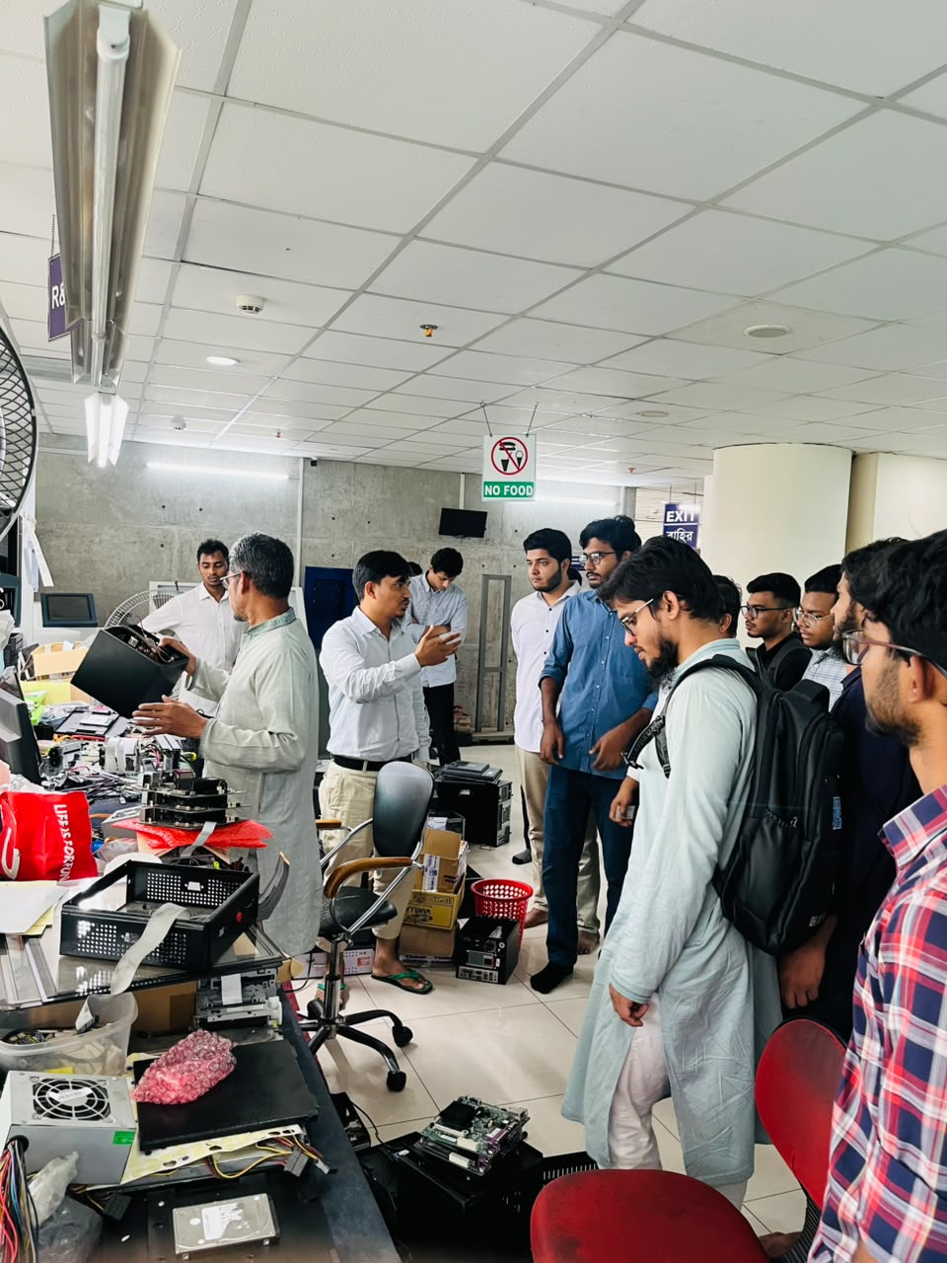

Visiting Assembly Unit Visiting R&D Unit
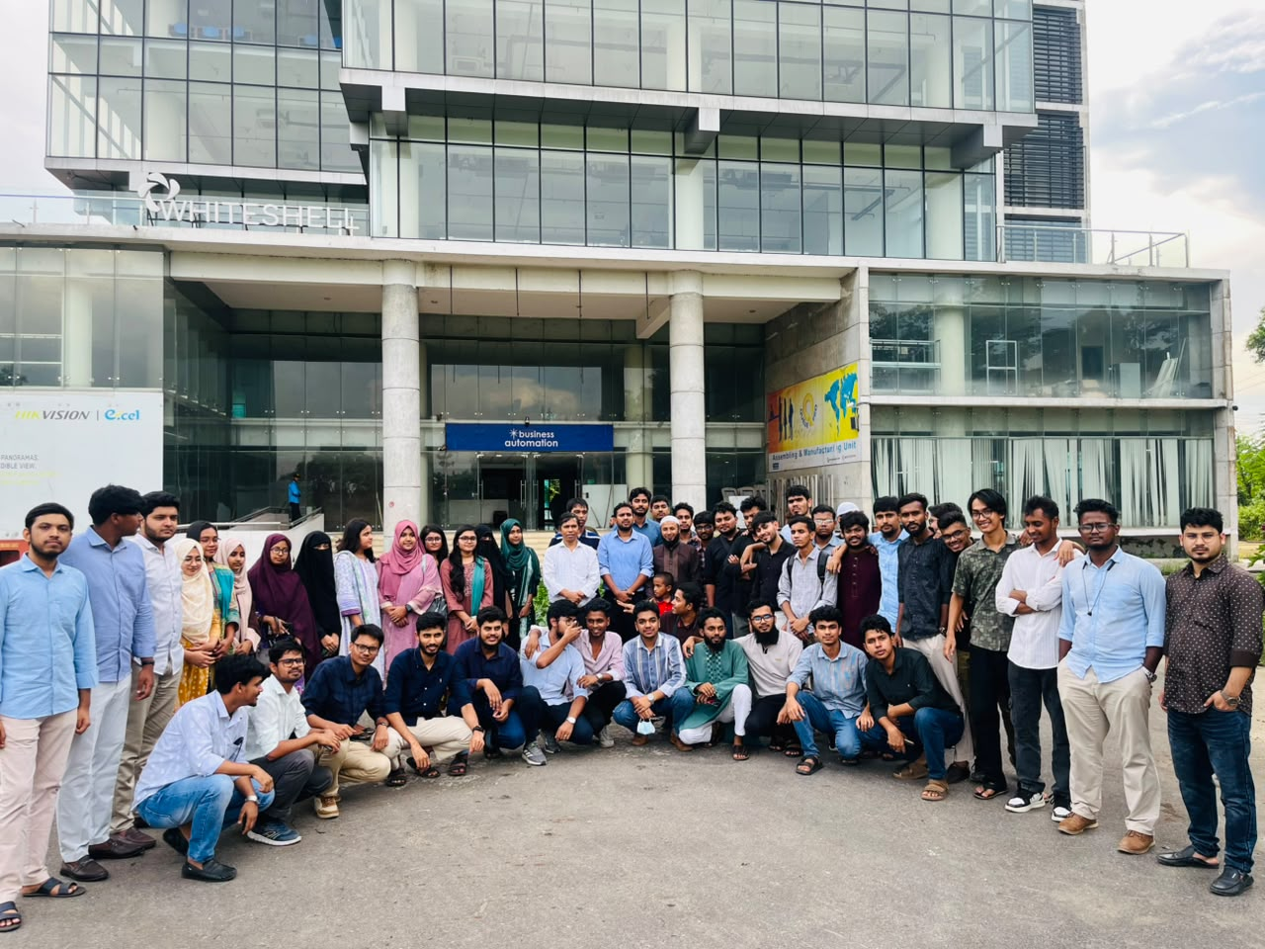

Group Photo In-front Of Business Automation Company

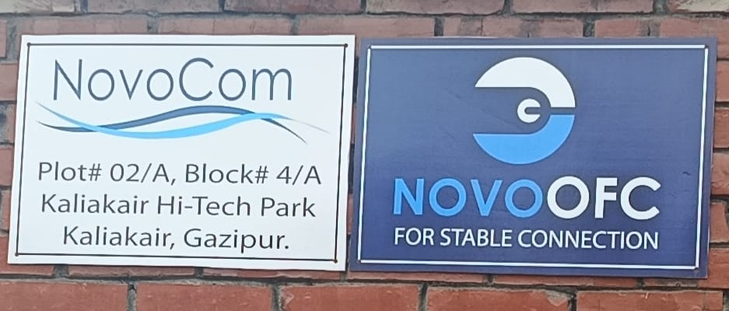

Second Company Visit in Hi-Tech Park
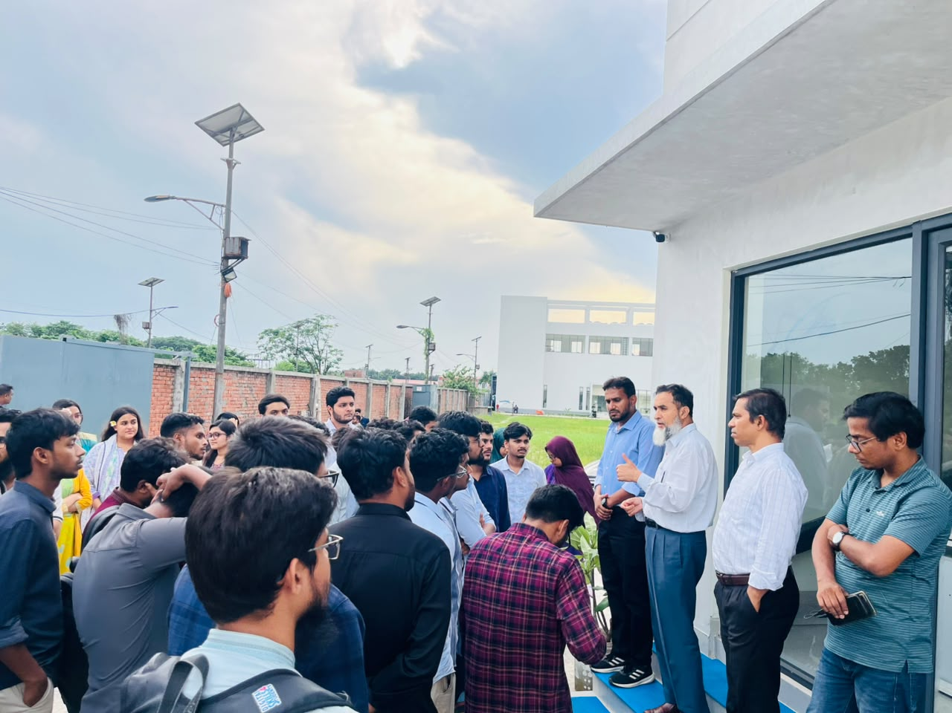

Short Briefing Before Entering NovoCom Factoy

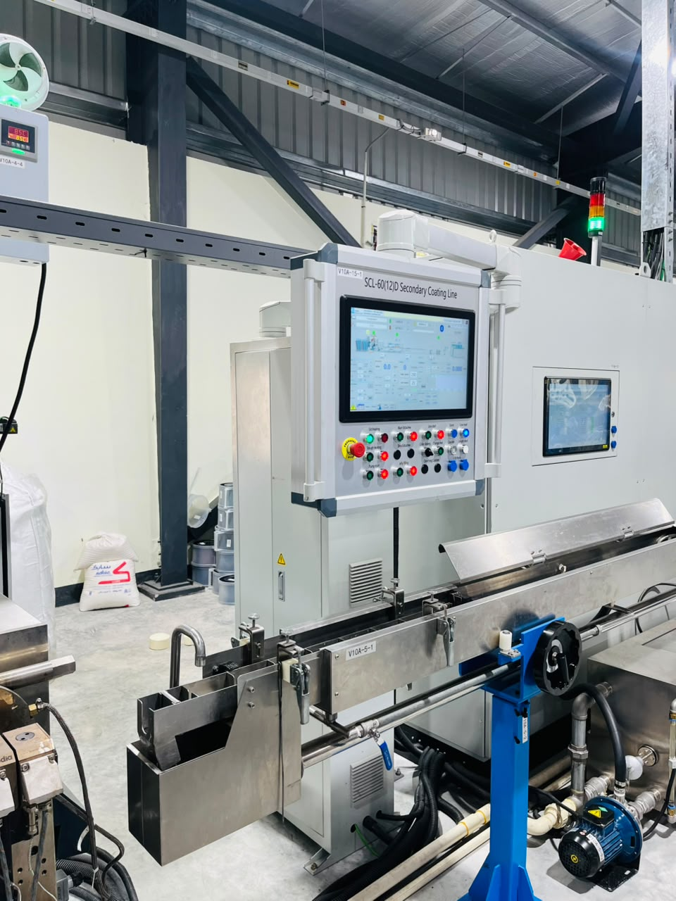
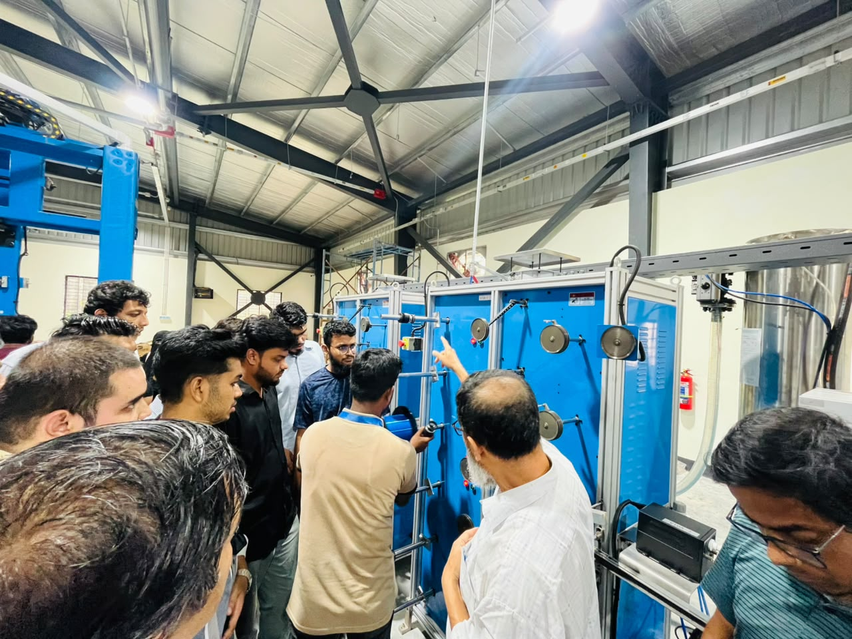

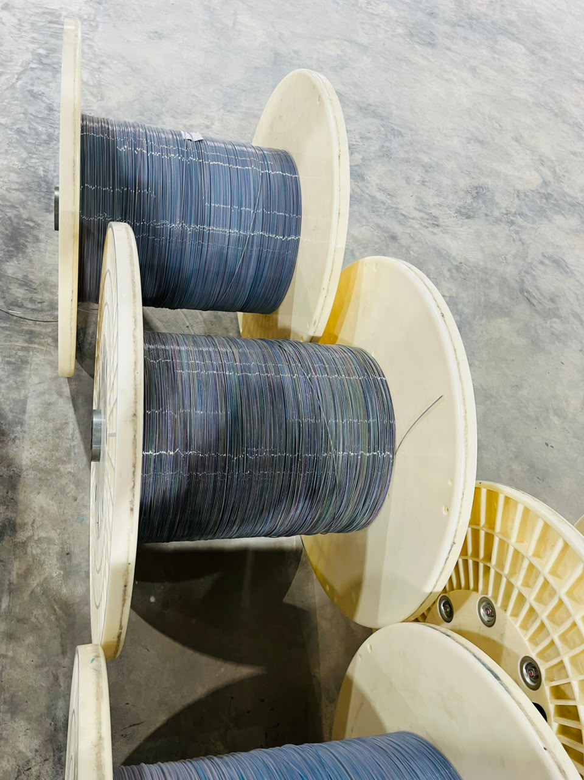

Visiting Optical Fiber Coating Line
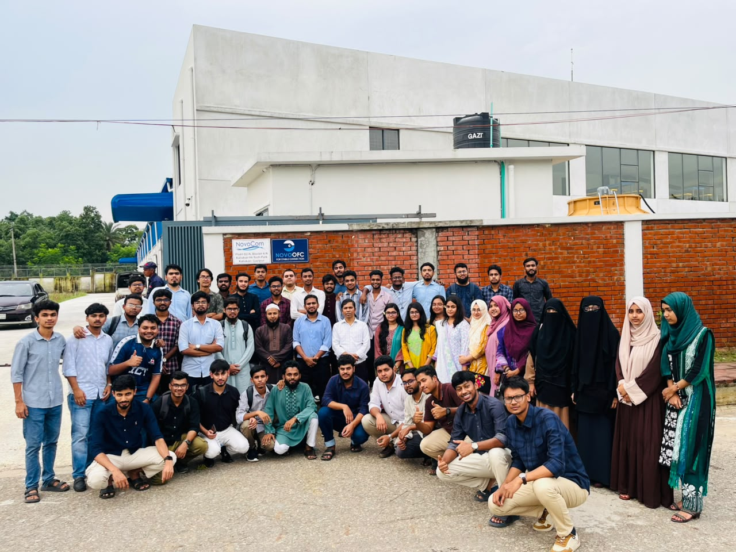

A Group Photo In-front of NovoCom Company

